# Entering Student Test Accommodations

Follow the procedure below to enter state testing accommodations for the student.

1. Open PowerSchool Admin and select a student.
2. 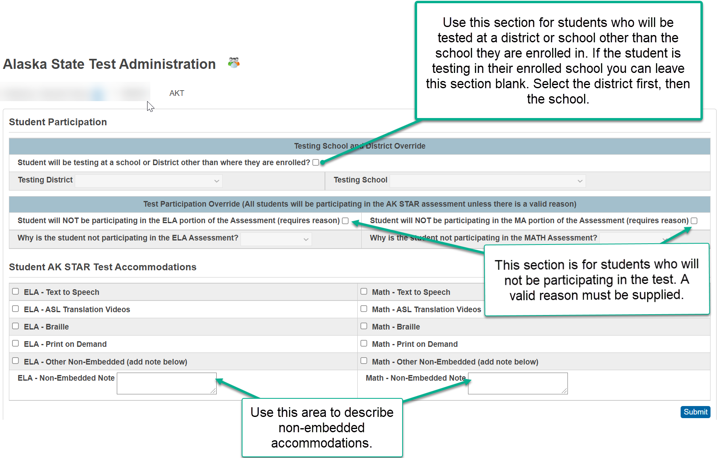Select **AK State Test Administration** under Administrationfrom the menu on the left.
3. For most students you will only need to check the boxes next to the necessary accommodations. If a student has a non-embedded accommodation, please enter them in the supplied note fields. The first two sections on the page are for special circumstances where the student is testing at another district or school. The second section is for students who will not be participating in the test for a valid reason.
4. 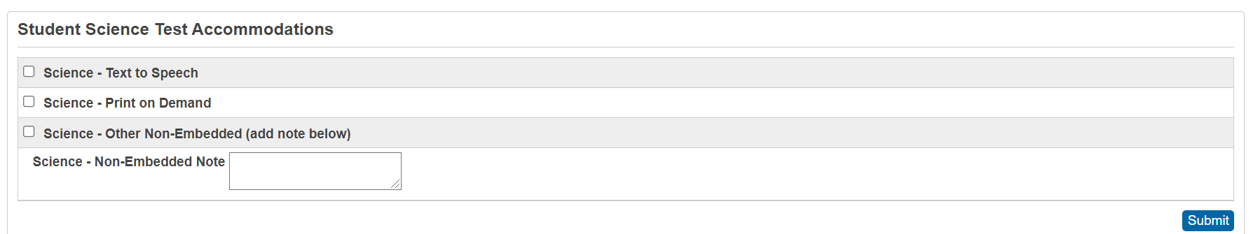The **Student Science Test Accommodations** section will only appear for students in grades 5, 8, and 10 (shown below). In grade 10 it is the only section that will appear.
5. Once the form has been filled out completely you can click on the **Submit** button.
6. A school-level report of all accommodations can be found from the PowerSchool start page on the System Reports page near the bottom. The Student Test Accommodations report cannot be found at the District Office level.